Job: Update KiCAD amplifier schematic and prep BOM for assembly

Notes:

This layout uses repeating blocks. Some changes are required on the main board, others on the repeating blocks. Changes in the repeating blocks must be made in two places, “AmpBlock” and “AmpBlockFlipped”.

Tasks:

1. Add two polarity reversal protection diodes. EGP51G-E3/CGICT-ND. One should point from -V to ground, the other from ground to +V.
2. Add 1727-5056-2-ND steering diodes for protecting 32 inputs to op-amps. Fit in on repeating block. Pin 1 connects to amplifier block input, pin 2 connects to +48 V, pin 1 connects to -48 V.
3. Add coax pickoff H9161TR-ND to amplifier block input, ground the shield to INPUT_COM (not to GND).
4. Add optional grounding jumper ED3264-02-ND in four places on the main board, replacing what are now labeled as R259-262. Also replace the two grounding resistors on each block with a single grounding jumper. (in block 1, these are R193, R194).

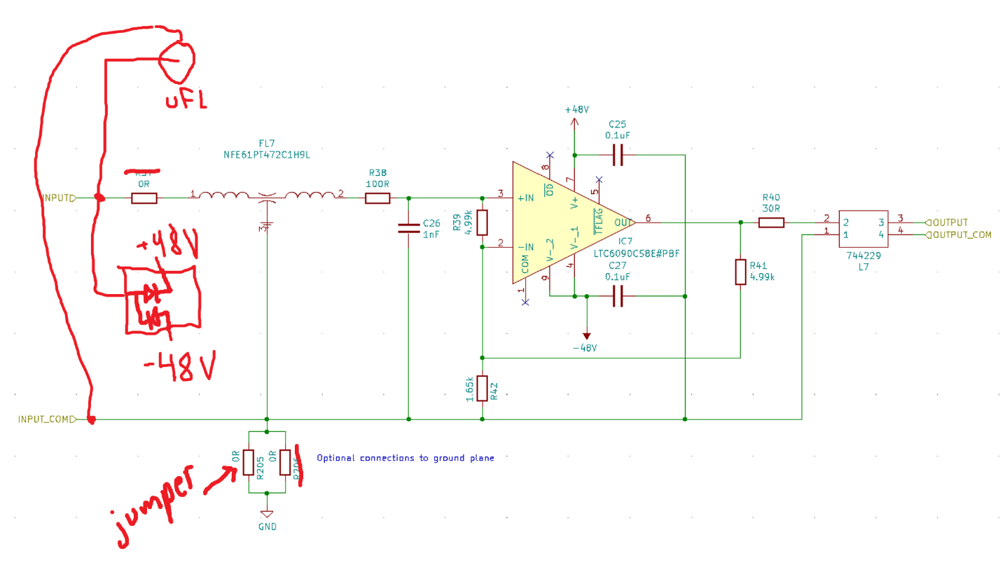

1. Layout and Route Board.
2. Prepare Gerbers.
3. Prepare BOM and CPL files based on provided component list. By the way, this file summarizes what I need to give to advanced circuits, my manufacturer: [Advanced Circuits Board Assembly](http://www.4pcb.com/Assembly%20Requirements%20(1-5-2016).pdf?_ga=2.93335197.1202224452.1645815254-1982584963.1644894451). Here’s some discussion on how to get them from KiCAD in case it is new to you: [generate-bom-and-centroid-file-from-kicad](https://support.jlcpcb.com/article/84-how-to-generate-the-bom-and-centroid-file-from-kicad).
4. Component List:
   1. Main Board:
      1. 277-1578-ND , 3 pin screw terminal, J1
      2. A31814-ND, HD68 connector, J2-3
      3. 1276-1838-1-ND, 1uF, C1-2,5-6
      4. 565-1365-ND, 22uF, C3-4
      5. 565-3338-1-ND, 10uF, C103-118
      6. RMCF0805ZT0R00CT-ND, 0k short, R257-258.
      7. A30916-ND, 2-pin header, R259-262. (jumper, 609-6251-ND)
      8. EGP51G-E3/CGICT-ND, diode, add to main board between +48 and GND, GND and -48
   2. Amp Block:
      1. 505-LTC6090CS8E#PBF-ND (mouser has more stock: 584-LTC6090CS8E#PBF), IC1
      2. 1727-5056-2-ND, steering diode add between block input, +/-48 V.
      3. H9161TR-ND, uFL coax pickoff, add at block input.
      4. 1276-6807-1-ND, 0.1u, C7,9
      5. 1292-1380-1-ND, 1000p, C8
      6. H11891TR-ND, u.FL connector
      7. 490-2554-2-ND, EMI Filter, FL1
      8. 311-100GRCT-ND, 100 ohm, R2
      9. CR0603-FX-4991ELFCT-ND, 4.99k, R3, R5
      10. RMCF0603FT1K65CT-ND, 1.65k, R6
      11. 738-RMCF0603FT30R0CT-ND, 30 ohm, R4
      12. RMCF0603ZT0R00CT-ND, R3, L2, 0 ohm
      13. 732-1488-1-ND, common mode choke, L1
      14. A30916-ND, 2-pin header, in place of R193 and R194. (jumper, 609-6251-ND)
      15. R1, remove from design